**LAPTOP REQUEST CATALOG ITEM USING SERVICE NOW**

**Project Description**

The Laptop Request Catalog Items project focuses on creating a digital self-service platform within ServiceNow that enables employees to request laptops efficiently and transparently. The system simplifies the entire request cycle — from submission and approval to allocation and delivery — through an automated workflow.Employees can select the desired laptop model from a predefined catalog, fill in minimal details, and submit their request online. Managers and IT administrators can review, approve, or reject requests based on availability and business needs. Real-time tracking and automated email notifications keep all stakeholders informed about the request status.This solution reduces manual interventions, ensures transparency in the approval process, and minimizes delays in hardware allocation. It enhances user experience, improves IT service efficiency, and supports faster onboarding of employees and project teams.

**Project Flow**

Milestone 1: Setting up service now instance.

Milestone 2: Creation of new update set.

Milestone 3: Creation of Service Catalog Item.

Milestone 4: Adding variables to the Item.

Milestone 5: Creation of Catalog Ui Policies.

Milestone 6: Creation of Ui Action.

Milestone 7: Exporting Changes To Another Instances.

Milestone 8: Retrieving The Update Set.

Milestone 9: Testing Catalog Item.

Milestone 9: Conclusion.

**Milestone 1: Setting Up ServiceNow Instance**

1. Sign up for a developer account on the ServiceNow Developer site “https://developer.servicenow.com”.
2. Once logged in, navigate to the "Personal Developer Instance" section.
3. Click on "Request Instance" to create a new ServiceNow instance.
4. Fill out the required information and submit the request.
5. You'll receive an email with the instance details once it's ready.
6. Log in to your ServiceNow instance using the provided credentials.
7. Now you will navigate to the ServiceNow.

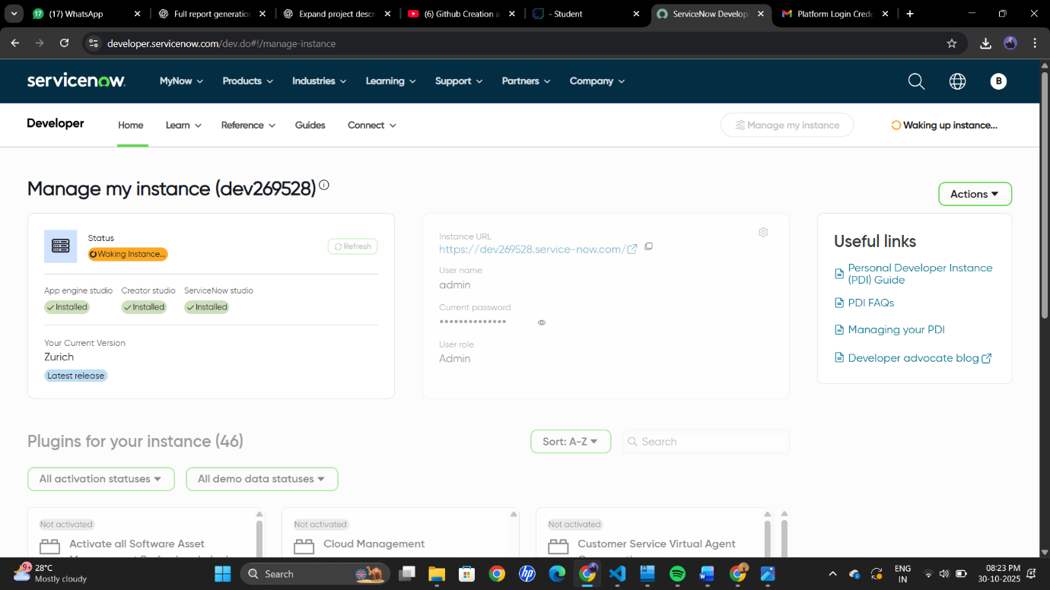

**Milestone 2: Creation Of New Update Set**

1. Open service now.
2. Click on All  >> search for update sets
3. Select local update sets under system update sets
4. Click on new
5. Fill the following details to create a update set as: “Laptop Request”
6. Click on submit and make current
7. By clicking on the button it activates the update set .

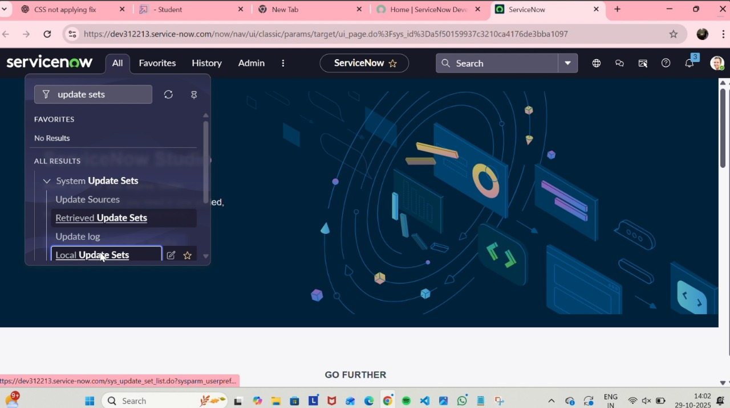

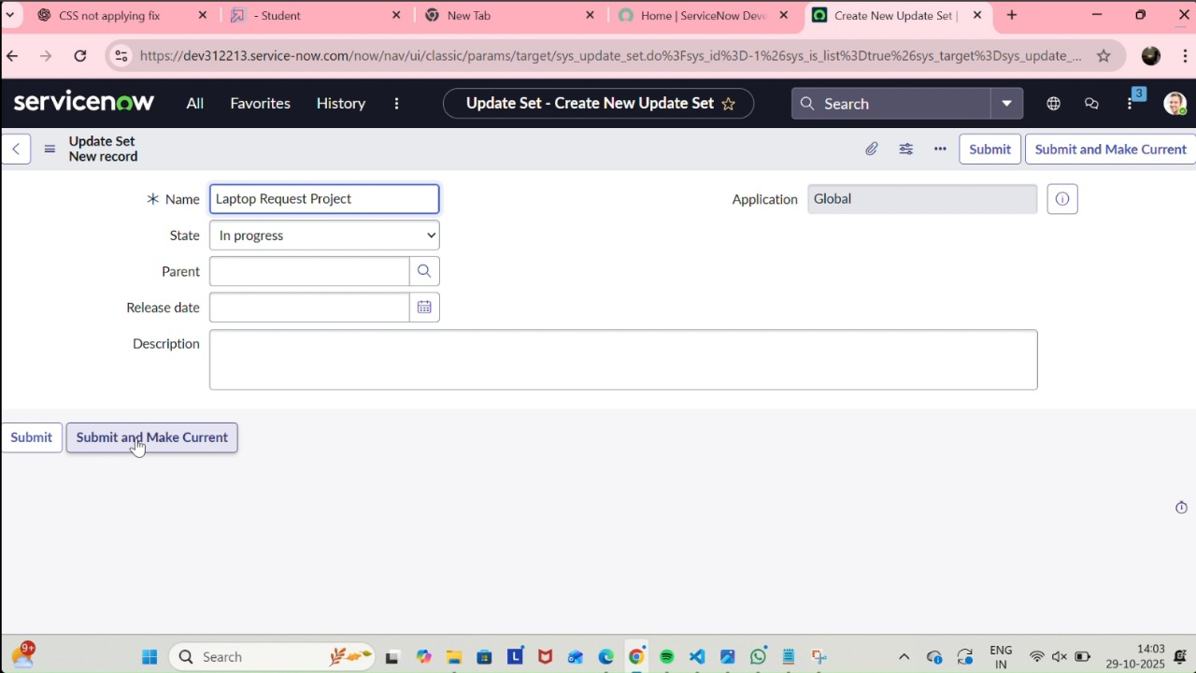

**Milestone 3: Creation Of Service Catalog Item**

1. Open service now.
2. Click on All  >> service catalog
3. Select maintain items under catalog definitions
4. Click on New.

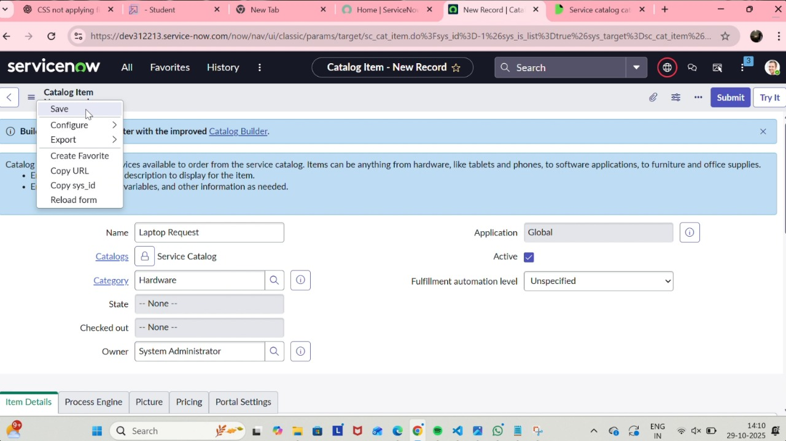

1. Fill the following details to create a new catalog item

            Name: Laptop Request

            Catalog: service Catalog

            Category: Hardware

            Short Description: Use this item to request a new laptop

1. Click on ‘SAVE’

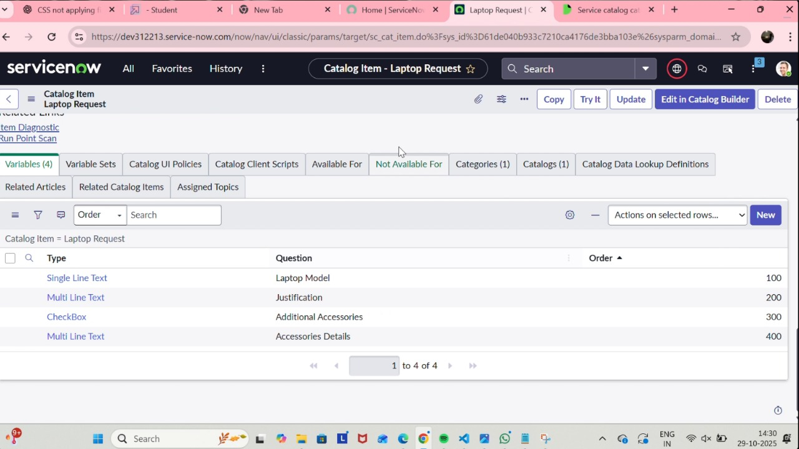

**Milestone 4: Adding Variables to the Item**

**Step1:**

1. After saving the catalog item form scroll down and click on variable(related list)
2. Click on new and enter the details as below
3. 1. Variable 1:Laptop Model Type: Single line text Name: laptop_model Order:100
4. Click on submit
5. Again click on new and add Remaining variables in the above process

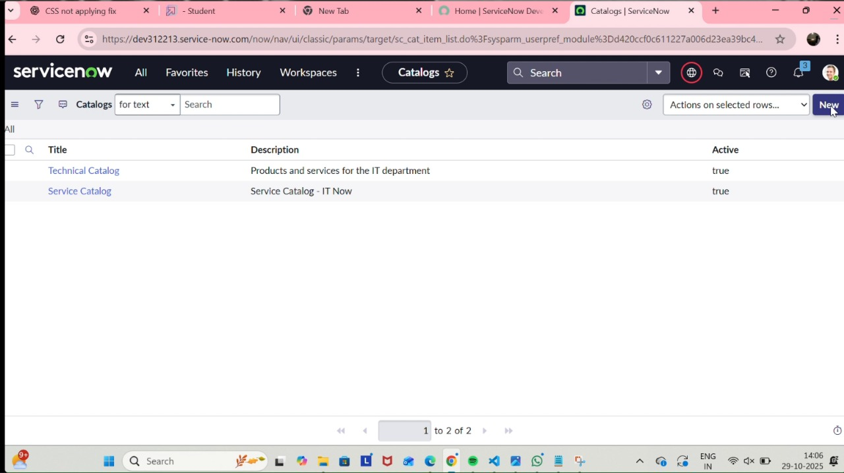

2. Variable 2:Justification

             Type: Multi line text

             Name: justification

             Order:200

     3. Variable 3:Additional Accessories

             Type: Checkbox

             Name: additional_accessories

             Order:300

     4. Variable 4: Accessories Details

             Type: Multi line text

             Name:accessories_details

             Order:400

**Step2:**

1. After adding above variable which are added to newly created catalog item
2. Then save the catalog item form

**Milestone 5: Creation Of Catalog Ui Policies**

1. Click on all>> search for service catalog
2. Select maintain item under catalog definition
3. Search for ‘laptop request’ which is created before
4. Select ‘laptop request’ and scroll down click on “Catalog Ui policies”
5. In the catalog ui policies related list tab click on new
6. Give short description as: show accessories details
7. Set the Catalog Condition in the related list tab ‘when to apply’ [field: additional_ accessories, operator: is, value: true]

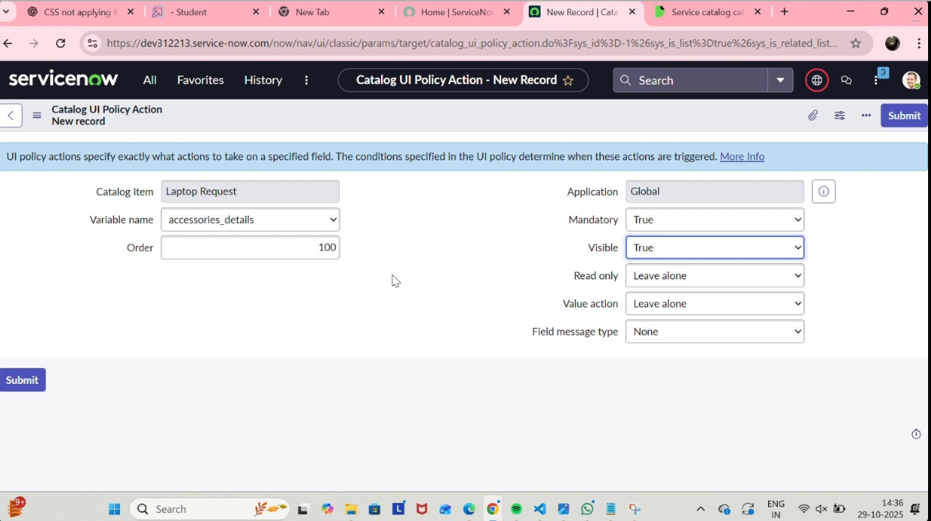

1. Click on **save**.(do not click on submit)
2. Scroll down and select ‘catalog ui action’
3. Then click on new button

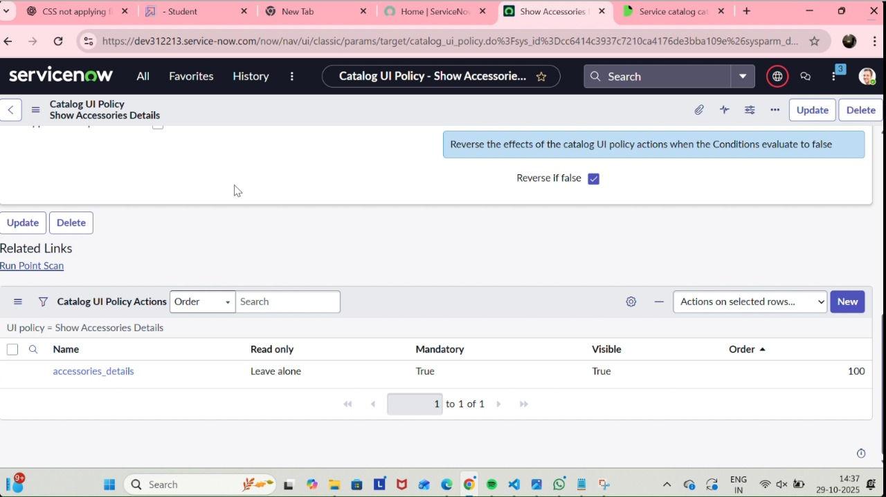

1. Select variable name as: accessories_details

                              Order:100

                    Mandatory: True

                         Visible : True

12. Click on save and again click save button of the catalog ui policy form

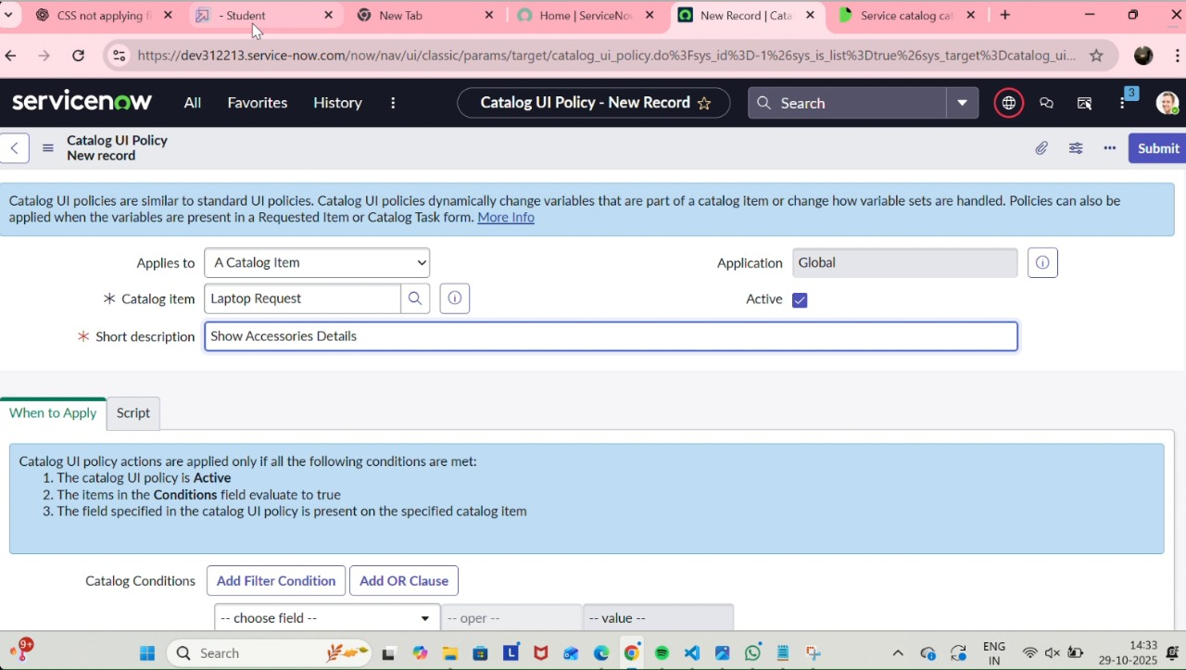

**Milestone 6: Creation of Ui Action**

1. Open service now.
2. Click on All  >> search for ui action
3. Select ui actions under system definition
4. Click on new
5. Fill the following details to create ui action

              Table: shopping cart(sc_cart)  
              Order:100  
              Action name:  Reset form  
               Client : checked

Script:  
    function resetForm() {  
    g_form.clearForm(); // Clears all fields in the form  
    alert("The form has been reset.");  
}  
 6. Click on save

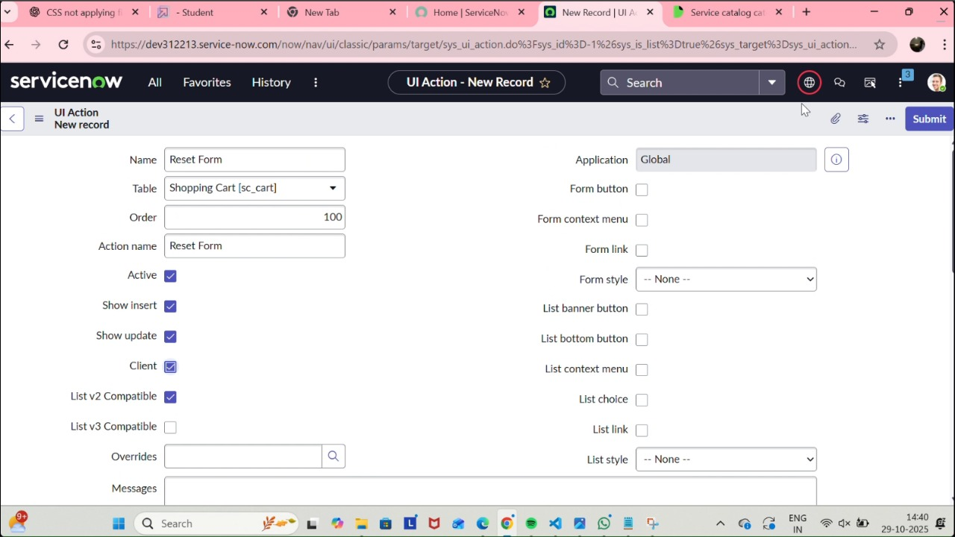

**Milestone 7: Exporting Changes To Another Instances**

1. Click on All  >> search for update sets
2. Select local update set
3. Select created update set i.e. ‘Laptop Request Project’
4. Set the state to ‘Complete’
5. In the related list Update tab, updates are visible which we perform under this update set.
6. Click on export to XML ,it download one file

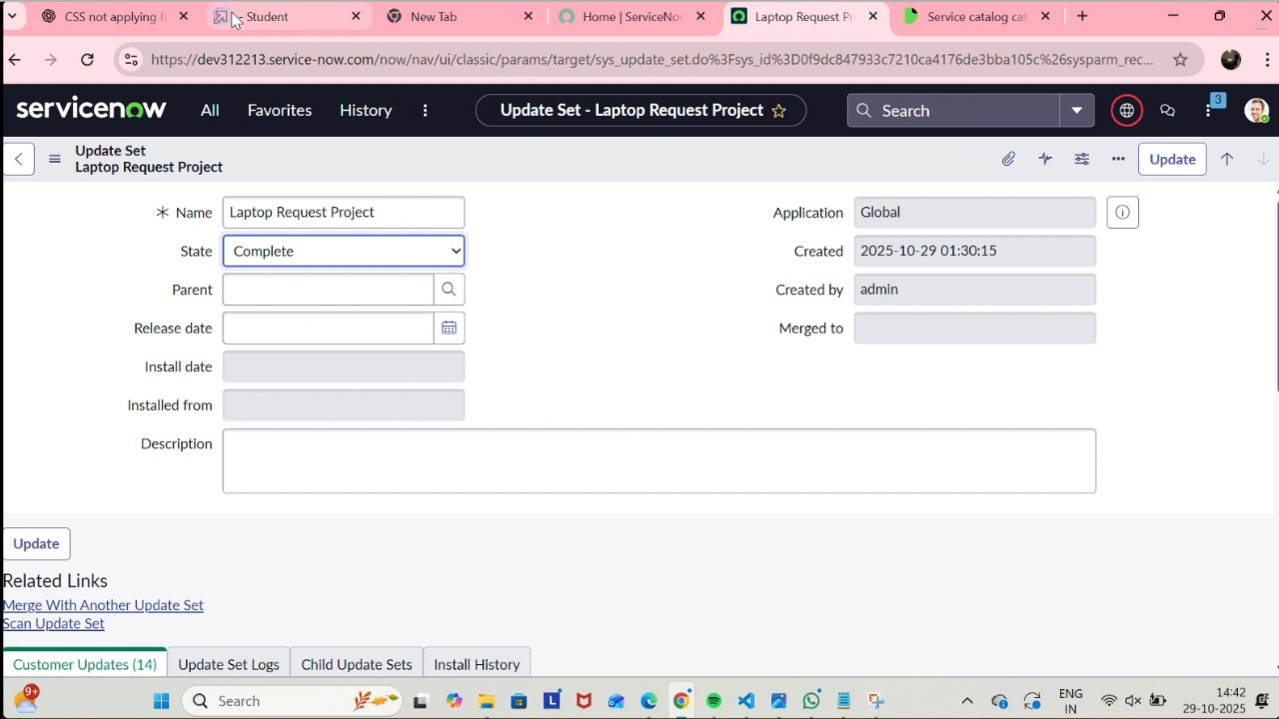

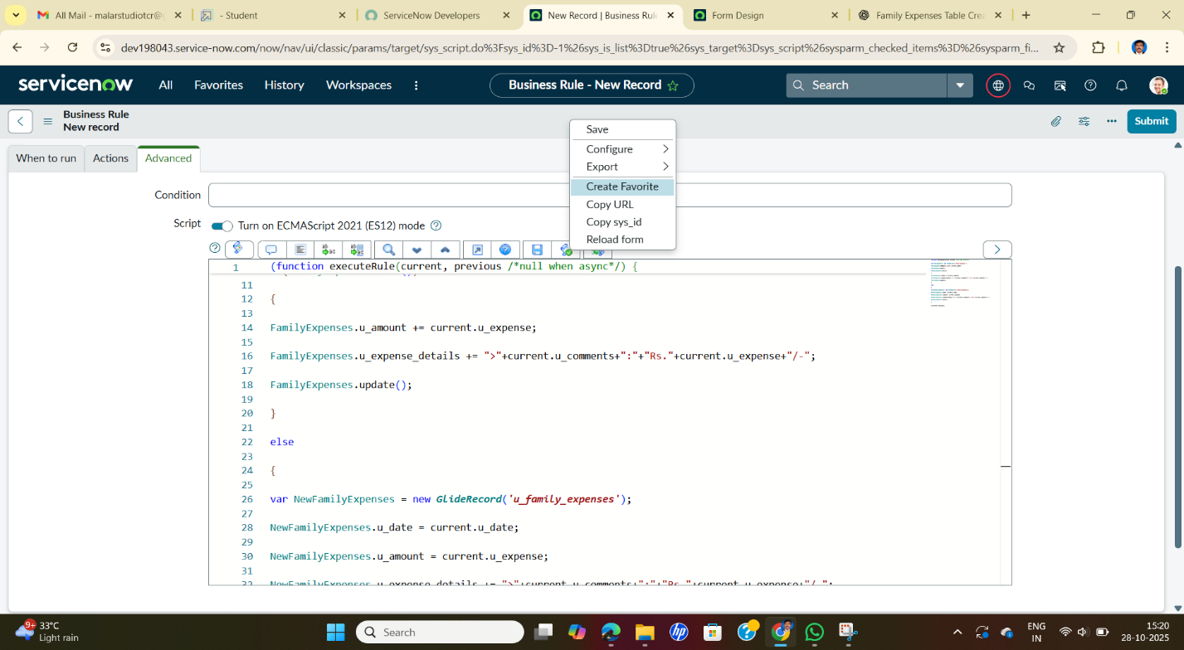

**Milestone 8: Retrieving The Update Set**

1. Open another instance in incognito window
2. Login with credentials
3. Click on all>> search for update sets
4. Select “Retrieved update set” under system update set

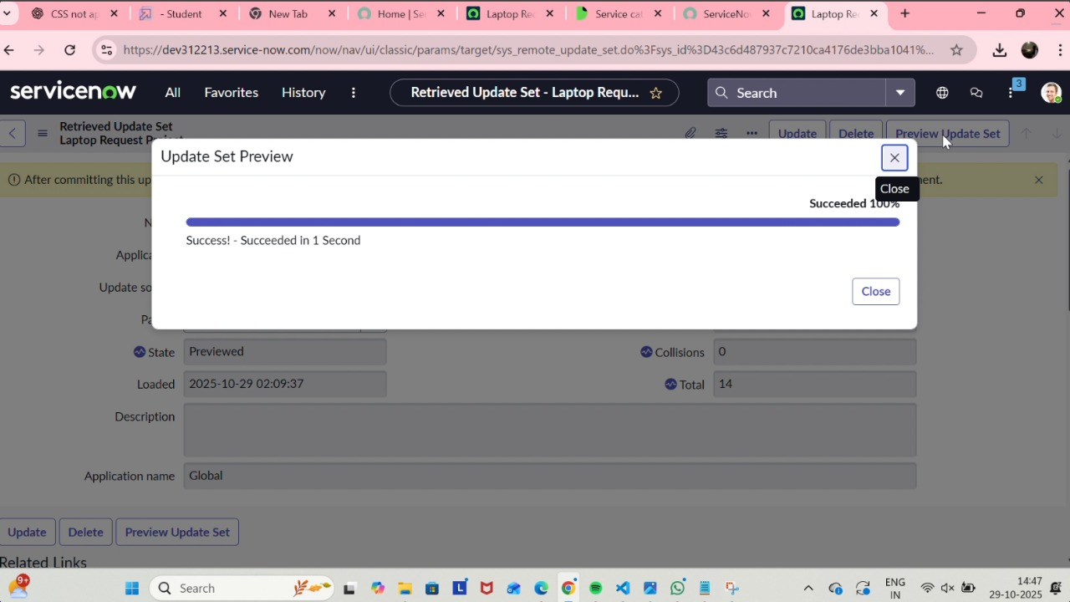

1. It open retrieved update set list and scroll down
2. Click on Import update set from XML
3. Upload the downloaded file in XML fileClick on Upload and it gets uploaded.

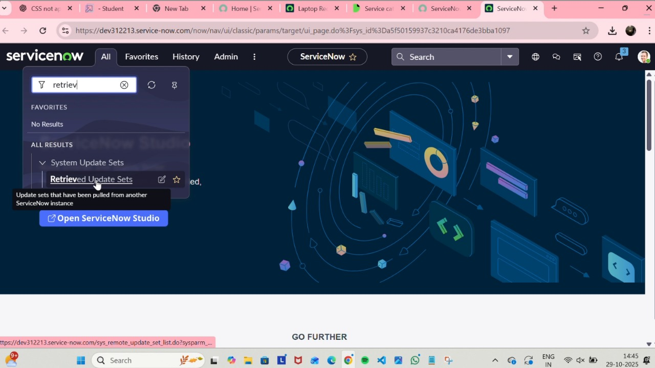

1. Open retrieved update set ‘laptop request project’
2. Click on preview update set
3. And click on commit update set

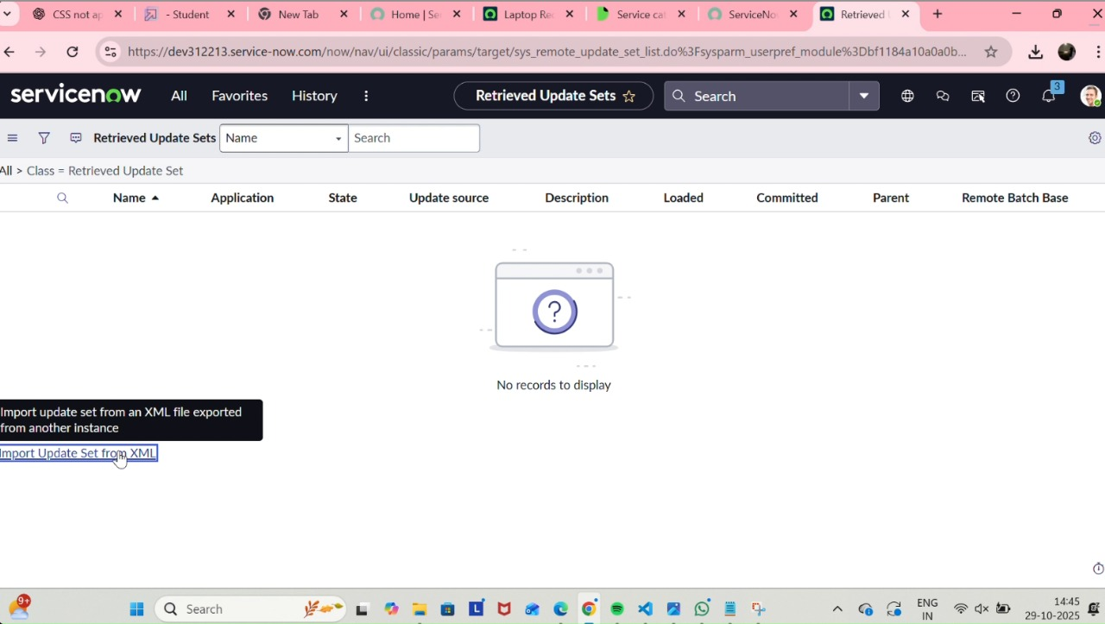

1. Upload the downloaded file in XML fileClick on Upload and it gets uploaded.
2. And also see the related tab updates
3. After commiting update set in this instance we get all updates which are done in the previous instance



**Milestone 9: Testing Catalog Item**

1. Search for service catalog in application navigator in target instance
2. Select catalog under service catalog
3. Select  hardware category and search for ‘laptop request’ item
4. Select laptop request item and open  it
5. It shows three variables only
6. As per our scenario, when we click on additional accessories checkbox then accessories details fields is visible and that should be mandatory
7. Now  see the results,it fulfills our requirements.

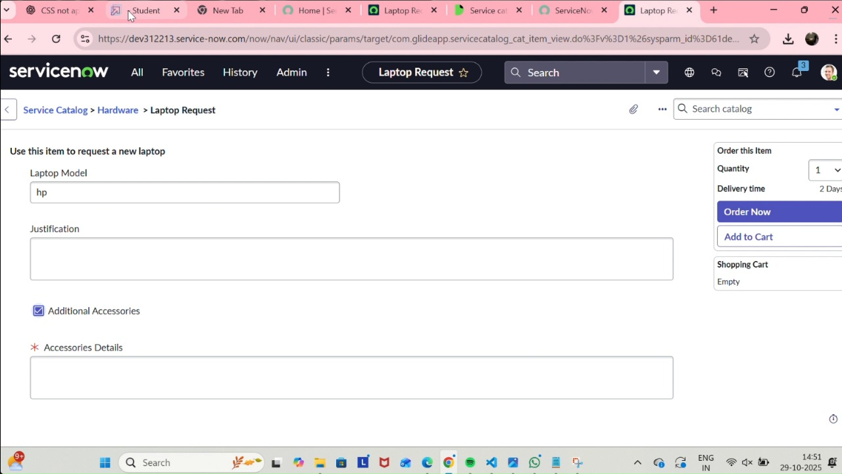

**Milestone 10: Conclusion**

The Laptop Request Catalog Item project successfully streamlines the process of requesting laptops within the organization by leveraging ServiceNow's Service Catalog capabilities. Through the implementation of a dynamic catalog item, the project ensures that users have an intuitive and user-friendly interface, reducing errors and improving efficiency.This project demonstrates how ServiceNow can be used to replace manual, error-prone processes with automated, efficient, and user-centric solutions. It not only improves service delivery but also enhances employee satisfaction by providing a modern and streamlined request experience.